ActionAid Agroecology: Lesson Plan – to be used over two classes

Materials:
- Flipchart/White Board
- A3 Paper
- Markers
- Laptop and projector
- Notebooks and pens

Purpose: To teach the students about agroecology as a solution to the climate crisis

Class 1: 40 minutes
- True or False Presentation – ten minutes
Use the PowerPoint provided: ask students to stand up. Point to one end of the room for false and the other end of the room for true. When you call out a statement ask students to move to one end of the room or the other. Ask students at each end why they are there.

Then move the PowerPoint on to reveal answers

- Human activities, through emissions of greenhouse gases, have caused global warming.
- True.
- Climate change is already affecting weather and climate extremes in every region across the globe, with negative impacts to nature and people.
- True
- Vulnerable communities who have contributed the least to current climate change are the most impacted by climate change.
- True
- There is nothing we can now do about climate change.
- False - some future changes are unavoidable but can be limited by deep, rapid and sustained global greenhouse gas emissions reduction.

Intergovernmental Panel on Climate Change

- What are the main causes of greenhouse gas emissions? - ten minutes
Ask students What are the main causes of greenhouse gas emissions? Students can call out answers. Use the white board/flip chart and markers and write down the examples.

Next slide of the Powerpoint lists some of the biggest polluters:
- Burning coal, oil and gas. This includes transportation like cars and airplanes, heating our homes, using electricity and manufacturing products.
- Cutting down forests (deforestation). Trees help to regulate the climate by absorbing CO₂ from the atmosphere. When they are cut down, that beneficial effect is lost and the carbon stored in the trees is released into the atmosphere, adding to the greenhouse effect.
- Increasing livestock farming. Cows and sheep produce large amounts of methane when they digest their food.
- Fertilisers containing nitrogen produce nitrous oxide emissions.
Burning coal, oil and gas are the biggest source of greenhouse gas emissions, however the next biggest source is agriculture which is associated with cutting down forests, livestock farming and fertilisers.
- What is agroecology and climate benefits of agroecology (five minutes)
Use the presentation to provided:
What is agroecology?
- Agroecology is sustainable farming that works with nature, rather than against it.
- By adding nutrient and carbon-rich organic matter such as compost and manure to soils, agroecology avoids the need for climate-harming and soil-degrading synthetic nitrogen fertilisers.
- Agroecology promotes biodiversity by planting multiple varieties of crops.
- Rich, naturally healthy soils can lead to abundant yields.
Climate benefits of agroecology
- Agroecology is sustainable farming that works with nature, rather than against it.
- By adding nutrient and carbon-rich organic matter such as compost and manure to soils, agroecology avoids the need for climate-harming and soil-degrading synthetic nitrogen fertilisers.
- Agroecology promotes biodiversity by planting multiple varieties of crops.
- Rich, naturally healthy soils can lead to abundant yields.

- Video explaining what agroecology is (five minutes)
Agroecology - the next evolution in food systems
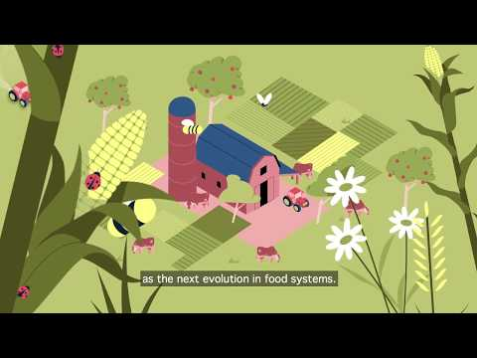

- Case study – five minutes

As well as helping to reduce emissions, agroecology has been used over the past number of years to support farmers who are already experiencing the effects of climate change and rising food and fertiliser prices.

Martha Isaac, a farmer and mother from Otutuoma, Nigeria shared said:

“The flood in 2022 chased me from where I was staying before to this place. I thought I had escaped the flood, but it still affects this area. Our cassava was destroyed and even the ones that the flood did not touch, when we got there after the flood, it had got rotten.
“ActionAid taught us agroecology; and it has helped us. We no longer buy chemical fertilizers. They taught us to make our own fertilizers. We store our leftovers, cassava peels, to make our own manure. We no longer waste money buying fertilizers. From this knowledge I can also teach other people how to make manure and they can also save their money.”
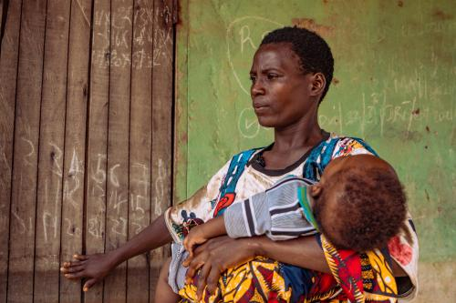
Nora Awolowo/ActionAid

- To think about at home (five minutes)
Show students the next slide and ask them when they go home to think about the following questions. Tell them that discussing these questions will be the focus of the next class
- Do you think agroecology is a solution to the climate crisis?
- How can it help?
- What are the challenges of agroecology? (Hints could include that there are lobbyists who promote the use of pesticides, it can be difficult for people to transition to new ways of farming).
- What do consumers need to do to support agroecology and cut down on emissions from food? (Hints could be eat locally sourced organic produce, eat less meat and dairy products, buy from small producers and eat seasonally to cut down on food miles)
- What are the limitations of agroecology? (Hints agriculture is a really important factor in tackling the climate crisis, but is part of an array of solutions that could include moving away from fossil fuels and excess consumption)
- Do you think we can feed the world in a way that is environmentally respectful and sustainable?

Class 2 – 40 minutes

- Recap – take ten minutes to discuss the previous s session, in particular, look again at the slides on what agroecology is:

What is agroecology?
- Agroecology is sustainable farming that works with nature, rather than against it.
- By adding nutrient and carbon-rich organic matter such as compost and manure to soils, agroecology avoids the need for climate-harming and soil-degrading synthetic nitrogen fertilisers.
- Agroecology promotes biodiversity by planting multiple varieties of crops.
- Rich, naturally healthy soils can lead to abundant yields.
Climate benefits of agroecology
- Agroecology is sustainable farming that works with nature, rather than against it.
- By adding nutrient and carbon-rich organic matter such as compost and manure to soils, agroecology avoids the need for climate-harming and soil-degrading synthetic nitrogen fertilisers.
- Agroecology promotes biodiversity by planting multiple varieties of crops.
- Rich, naturally healthy soils can lead to abundant yields.

- Class Activity – twenty minutes

Ask students to break into pairs, spend ten minutes discussing the video and case study, prompts could be:
- Do you think agroecology is a solution to the climate crisis?
- How can it help?
- What are the challenges of agroecology? (Hints could include that there are lobbyists who promote the use of pesticides, it can be difficult for people to transition to new ways of farming).
- What do consumers need to do to support agroecology and cut down on emissions from food? (Hints could be eat locally sourced organic produce, eat less meat and dairy products, buy from small producers and eat seasonally to cut down on food miles)
- What are the limitations of agroecology? (Hints agriculture is a really important factor in tackling the climate crisis, but is part of an array of solutions that could include moving away from fossil fuels and excess consumption)
- Do you think we can feed the world in a way that is environmentally respectful and sustainable?

Afterwards, take ten minutes to ask students to call out answers and write them on the white board/flip chart / discuss as a class

- Reflections – five minutes

Ask students to spend five minutes reflecting in their notebooks, you can ask them the following questions to reflect on.
- What had you heard about farming and climate change before and where had you heard about it? (from media, friends and family, just around)
- Who has the power/control when it comes to climate change? Who loses and who benefits?
- Whose perspectives do you usually hear from when it comes to climate action and farming?

- Take action – five minutes:
Turn back to the presentation and provide some suggestions of how students can take action:
- Talk about climate change with your friends and family
- Discuss as a class ways that you can work together with your community on climate action.
- Write to your local politician or local newspaper outlining the changes that you would like to see

(If your students would like support with taking further action you hand out our take action guides on our website – available here: https://actionaid.ie/speech-writing-competition)

- Take part in ActionAid’s ActionTalks speech writing competition, writing a speech on the topic:
- Agroecology, which is farming that works with nature, is one solution to the climate crisis at home and abroad. Discuss making reference to women’s rights.
- First prize is a €500 voucher – learn more at www.actionaid.ie

Further reading
- https://www.ipcc.ch/report/ar6/syr/downloads/report/IPCC_AR6_SYR_SPM.pdf
- Shifting Funding to Agroecology: https://www.actionaidusa.org/publications/shifting-funding-to-agroecology-fo-people-climate-and-nature/
- Agroecology scaling up and scaling out: https://www.actionaidusa.org/publications/agroecology/
- Principles for a Just Transition in Agriculture: https://www.actionaidusa.org/publications/principles-for-a-just-transition-in-agriculture/
- Why food production is central to the crises we face: https://www.actionaidusa.org/insight/back-to-the-land-why-food-production-is-central-to-the-global-crises-we-face/
- How the Finance flows: The banks fueling the climate crisis and Ireland’s role in enabling this https://actionaid.ie/wp-content/uploads/2023/09/ActionAid-Ireland-How-the-Finance-Flows.pdf

