ActionAid - Overseas aid and women’s rights organizations: Lesson Plan

40 minutes

Materials:
- Flipchart/White Board
- A3 Paper
- Markers
- Laptop and projector
- Notebooks and pens

- Official development assistance (ODA) and women rights organizations- three minutes

Ask students to use their notepad and pen and spend three minutes writing down what they think official development assistance (ODA) is and what they think women’s rights organisations do. Students can then call out answers.

- Go to the explainer of official development assistance (ODA) – two minutes
Use the PowerPoint provided to share the explainer on official development assistance (ODA). Ask students to write down any of the additional points that they didn’t have:

Official development assistance (ODA) is government aid that promotes and specifically targets the economic development and welfare of developing countries.

ODA has been the main source of financing for development aid since it was adopted by the Organisation for Economic Co-operation and Development (OECD)’s Development Assistance Committee (DAC) as the “gold standard” of foreign aid in 1969.

Click here for more information

- Video about ODA (two minutes)
https://youtu.be/fzVpsKdq0Fo

- True or False Presentation – five minutes

Use the PowerPoint provided: ask students to stand up. Point to one end of the room for false and the other end of the room for true. When you call out a statement ask students to move to one end of the room or the other. Ask students at each end why they are there.

Then move the PowerPoint on to reveal answers:

ODA rose in 2023, as provider countries increased aid flows to Ukraine and directed more humanitarian assistance to developing countries.

True.
Source: https://www.oecd.org/en/about/news/press-releases/2024/04/international-aid-rises-in-2023-with-increased-support-to-ukraine-and-humanitarian-needs.html

Official development assistance (ODA) continues to grow steadily in recent years, with more than 5% ODA aimed at ending violence against women and girls.

False. ODA for gender equality dropped from 45% in 2019-20 to 43% in 2021-22. Less than 1% of ODA is aimed at ending violence against women and girls.
Source: https://web-archive.oecd.org/temp/2024-03-07/73550-development-finance-for-gender-equality-and-women-s-empowerment.htm

Ireland has a governmental development cooperation programme.

True.
Source: https://www.ireland.ie/en/irish-aid/what-we-do/

Ireland recognises the central role of women’s rights organisations and is committed to supporting women’s rights organisations and women peacebuilders in conflict-affected and fragile states and humanitarian response.

True.
Source: https://www.ireland.ie/en/irish-aid/what-we-do/gender-equality/#organisations

- Go to the explainer of Irish Aid – two minutes

Use the PowerPoint provide to share the explainer on Irish Aid. Ask students to write down any of the additional points that they didn’t have:
- Irish Aid is the Government of Ireland’s development cooperation programme.
- Working with partners around the world, it reaches over 130 countries.
- The aim is to tackle poverty, hunger and humanitarian need and support long-term development programmes to help bring change and provide humanitarian support
- Ireland supports The Girls’ Fund. This fund provides funding to young feminists. Irish Aid has supported 26 groups around the world through The Girls’ Fund.

Click here for more information

- Video about Irish Aid – three minutes
https://youtu.be/HHKHzOO-0Iw

- Go to the explainer of the importance of women’s rights organizations – three minutes

- Women's rights organizations are essential in providing services to survivors and victims of gender-based violence (shelters, counseling, legal assistance, and hotlines).
- Local women’s rights organizations understand their communities and use evidence-based approaches that have reduced violence and transformed the lives of women, particularly marginalized and racialized women who are at greater risk.
- Women’s rights organizations had a critical role in driving government responses to tackling gender-based violence during the COVID-19 pandemic.
- While the number of women and girls in conflict-affected contexts is rising, researchers show that positive steps toward gender equality were achieved when women actively participated in the response efforts during conflict and emergencies.
- Many women’s rights organizations are underfunded with just 5 percent of the total Official Development Assistance allocated to ending violence against women reaching them.
Sources: https://www.unwomen.org/en/articles/explainer/how-funding-womens-organizations-prevents-violence-against-women
https://www.oecd.org/en/topics/development-co-operation.html

- Case study – five minutes
Female Genital Mutilation (FGM), is a violent procedure that involves partial or total removal of the external female genitalia which can cause severe bleeding, health issues, and even death. This practice is recognized internationally as a violation of the human rights of women and girls.
Despite being outlawed in Kenya since 2011, FGM remains a pressing issue in the country, and other parts of Africa.
The Kamuthe Women’s Network, funded by Irish Aid through ActionAid Ireland and ActionAid Kenya, are leading the charge in this region against FGM.
They manage a safe house and resource centre for young girls who flee FGM, forced child marriages and other forms of sexual violence.
“There has been considerable improvement in women’s and girls’ rights in Garissa County. Ten years ago, the space of women was limited, but combined efforts from various stakeholders including ActionAid have made women and girls in my community have a voice.” - Hawa Abdi Saha, County Executive Committee (CEC) for Gender in Garissa County
For more stories: https://actionaid.ie/makkas-story/
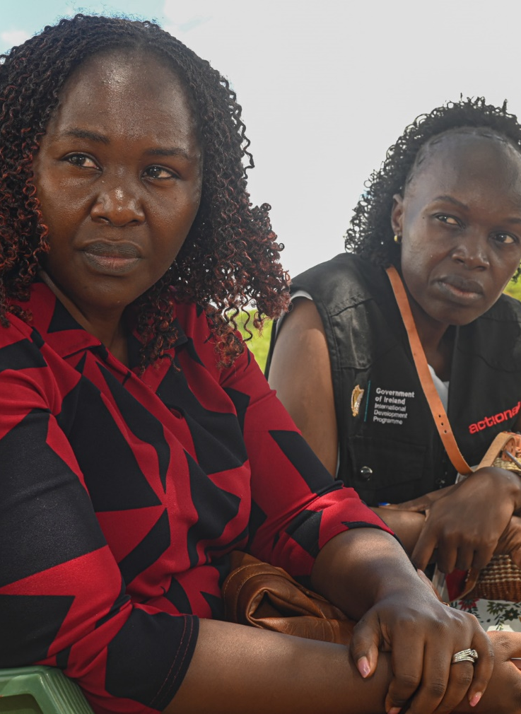

- Class Discussion – ten minutes

Ask students to break into pairs, spend five minutes discussing the following:

- Why do you think women’s rights organizations are still underfunded?
- What needs to happen to change this situation?
- What are the challenges for women’s rights organizations?
- What do citizens need to do to ensure that more aid directly supports women's organizations?
- Do you think that funding women's organizations can benefit communities and societies worldwide? If yes, which benefits this can bring?

Afterwards, take five minutes to ask students to call out answers and write them on the white board/flip chart.

- Reflections – two minutes

Ask students to spend two minutes reflecting in their notebooks, you can ask them the following questions to reflect on.
- What had you heard about overseas aid and women’s rights organizations before and where had you heard about it? (from media, friends and family, just around)
- Who has the power and control when it comes to overseas aid and women’s rights organizations? Who loses and who benefits?
- Whose perspectives do you usually hear from when it comes to overseas aid and women’s rights organizations?

- Actions to take – three minutes

Turn back to the presentation and provide some suggestions of how students can take action:

- Talk about overseas aid and women’s rights organizations with your friends and family
- Discuss as a class ways that you can work together with your community to take action
- Write to your local politician or local newspaper outlining the changes that you would like to see

(If your students would like support with taking further action you hand out our take action guides on our website – available here: https://actionaid.ie/speech-writing-competition)

- Take part in ActionAid’s ActionTalks speech writing competition, writing a speech on the topic:
- Around the world, women experience violations of their human rights and higher levels of poverty than men. Despite this, just 5 per cent of Official Development Assistance allocated to ending violence against women reaches women’s rights organisations. The focus of overseas aid needs a radical reform to address the denial of women’s rights and gender inequality globally. Discuss.
- First prize is a €500 voucher – learn more at www.actionaid.ie

Further resources
- https://actionaid.ie/womens-rights-programme/
- https://www.actionaid.org.uk/our-work/vawg/womens-rights-organisations

