ActionAid - The impacts of climate change on women’s rights: Lesson Plan
2 classes – 40 minutes each
Materials:
- Flipchart/White Board
- A3 Paper
- Markers
- Laptop and projector
- Notebooks and pens
Purpose: To teach the students about the impacts of climate change on women’s rights.
Class 1- 40 minutes
- What is climate change? - three minutes
Ask students to use their notepad and pen and spend three minutes writing down what they think climate change is. Students can then call out answers.
- Go to the explainer of “What is climate change” – two minutes
Use the PowerPoint provided to share the explainer on “what is climate change.” Ask students to write down any of the additional points that they didn’t have:
- Climate change is long-term change in the average weather and temperatures patterns that have come to define Earth’s local, regional and global climates.
- Starting from the 1800s, human activities have been the main driver of climate change, primarily due to the burning of fossil fuels like coal, oil and gas.
- The consequences of climate change include intense droughts, water scarcity, severe fires, rising sea levels, flooding, melting polar ice, catastrophic storms and declining biodiversity.
You can find more information here: https://www.un.org/en/climatechange/what-is-climate-change
- Go to the climate change dictionary – five minutes
Use the PowerPoint provided to share some words related to climate change. Ask students to share if they know the meaning of some of the words and check the meaning here: https://climatepromise.undp.org/news-and-stories/climate-dictionary-everyday-guide-climate-change

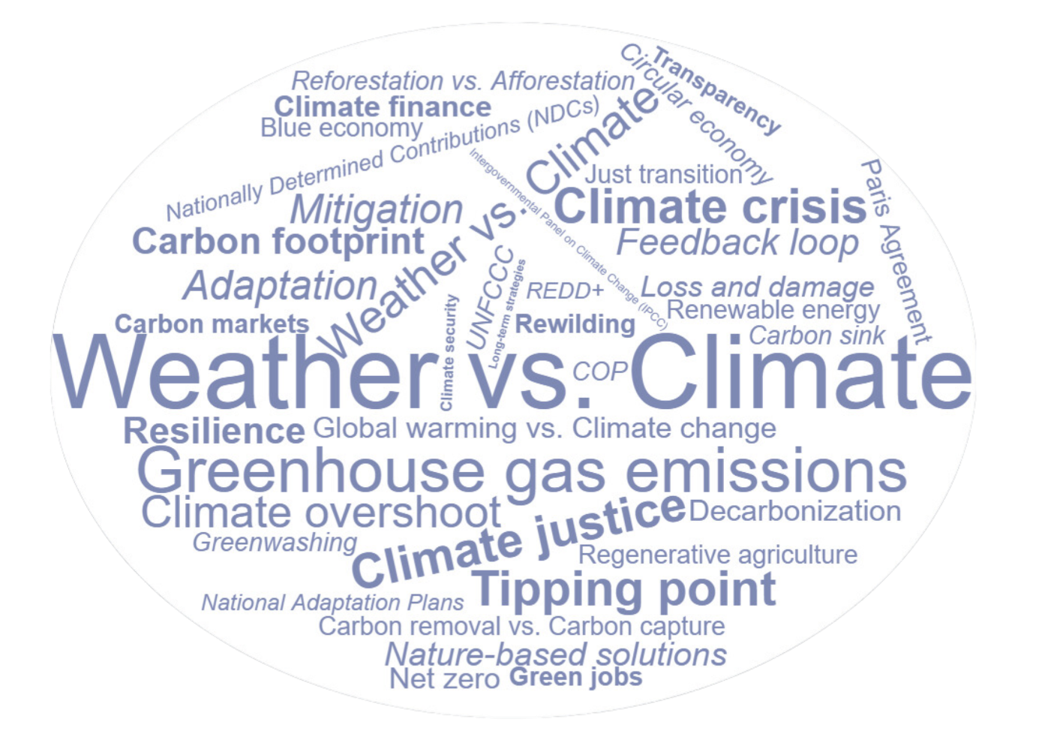

- Video explaining what climate change is – fives minutes
https://youtu.be/EtW2rrLHs08
- True or False Presentation – five minutes

Use the PowerPoint provided: ask students to stand up. Point to one end of the room for false and the other end of the room for true. When you call out a statement ask students to move to one end of the room or the other. Ask students at each end why they are there.

Then move the PowerPoint on to reveal answers

It is too late to avert a climate catastrophe, so we might as well keep burning fossil fuels.
False. While the situation is dire, there is still a narrow window for humanity to avoid the worst of climate change. UNEP’s latest Emissions Gap Report found that cutting greenhouse gas emissions by 42 per cent by 2030, the world could limit global temperature rise to 1.5°C compared with pre-industrial levels.
Source: https://www.unep.org/news-and-stories/story/debunking-eight-common-myths-about-climate-change#:~:text=Myth%20%234%3A%20An%20increase%20in,weather%20conditions%20in%20a%20region
Climate change affects everyone in the same way.
False. Even within the same country, the impacts of climate change may be felt unevenly due to structural inequalities based on race, ethnicity, gender, and socioeconomic status.
Example 1: In 2022, 19.1% of Ireland’s greenhouse gas emissions came from transportation. Reducing car use is crucial, but rural communities may be hit hardest since they depend on cars due to poor public transport. This can lead to "transport poverty," limiting access to social activities. Expanding public transport in these areas is essential to ensure everyone benefits fairly from climate actions.
Example 2: Women and children are 14 times more likely to die from climate disasters as men.
Source: https://climatepromise.undp.org/news-and-stories/climate-change-matter-justice-heres-why
Example 1: https://www.nwci.ie/images/uploads/NWC_CWI_FeministClimateJusticeReport_Web_%28compressed%29.pdf
Example 2: https://careclimatechange.org/evicted-by-climate-change/
- Class Activity – test your knowledge – five minutes
Choose one of these three activities and do it together with students to understand the knowledge on the topic or reflect on the impact we have on climate change
- Footprint calculator
- How much do you know about the basics of climate change?
- Test your knowledge on climate change
- Climate change and women’s rights - three minutes
Ask students to use their notepad and pen and spend three minutes writing down how they think climate change could impact women’s rights. Students can then call out answers.
- Go to the explainer of climate change and women’s rights – two minutes
Use the PowerPoint provided to share the explainer on climate change and women’s rights. Ask students to write down any of the additional points that they didn’t have:
Women and girls experience the greatest impacts of climate change:
- Agriculture is the most important employment sector for women in low- and lower-middle income countries, during periods of drought and erratic rainfall, women work harder to secure income and resources for their families. This puts added pressure on girls, who often must leave school to help their mothers manage the increased burden.
- As climate change drives conflict across the world, women and girls face increased vulnerabilities to all forms of gender-based violence.
- When disasters strike, women are less likely to survive and more likely to be injured due to long standing gender inequalities that have created disparities in information, mobility, decision-making, and access to resources and training.
- Women’s and girls’ health is endangered by climate change and disasters by limiting access to services and health care and increasing risks related to maternal and child health.
You can find more information here: https://www.unwomen.org/en/news-stories/explainer/2022/02/explainer-how-gender-inequality-and-climate-change-are-interconnected
Go to next slide- Climate change and women’s rights – EXAMPLES – 2 minutes
From a United Nations Population Fund (UNFPA) research, results shows that the countries most at risk of climate change are also those where women and girls are in greatest danger. Of the 10 countries most vulnerable to climate change:
6 also have the highest maternal death rates in the world
5 have the highest adolescent birth rates.
7 have the worst child marriage rates.
4 have the highest rates of intimate partner violence.
13 are experiencing a humanitarian crisis requiring assistance at the beginning of 2024.
Source: https://www.unwomen.org/en/news-stories/explainer/2022/02/explainer-how-gender-inequality-and-climate-change-are-interconnected
- Video explaining climate change and women’s rights – five minutes
https://edition.cnn.com/videos/world/2023/11/24/climate-change-women-impact-explained-as-equals-lon-orig.cnn

Class 2 – 40 minutes

- Recap – discuss the previous session focusing on the slides on climate change and women’s rights- five minutes

Women and girls experience the greatest impacts of climate change:
- Agriculture is the most important employment sector for women in low- and lower-middle income countries, during periods of drought and erratic rainfall, women work harder to secure income and resources for their families. This puts added pressure on girls, who often must leave school to help their mothers manage the increased burden.
- As climate change drives conflict across the world, women and girls face increased vulnerabilities to all forms of gender-based violence.
- When disasters strike, women are less likely to survive and more likely to be injured due to long standing gender inequalities that have created disparities in information, mobility, decision-making, and access to resources and training.
- Women’s and girls’ health is endangered by climate change and disasters by limiting access to services and health care and increasing risks related to maternal and child health.
You can find more information here: https://www.unwomen.org/en/news-stories/explainer/2022/02/explainer-how-gender-inequality-and-climate-change-are-interconnected

- Why climate action needs women - three minutes
Ask students break up into pairs or groups, and to use their notepad and pen and spend three minutes writing down why climate action needs women. Students can then call out answers.
- Go to the explainer of why climate action needs women– two minutes
Use the PowerPoint provide to share the explainer on Why climate action needs women. Ask students to write down any of the additional points that they didn’t have:

- Women are crucial in building climate resilience in communities. They are usually first responders in community responses to natural disasters, leaders in disaster risk-reduction, and contribute to post recovery by addressing the early recovery needs of their families and communities.
- Women often face higher risks and greater burdens from the impacts of climate change in situations of poverty and due to existing roles, responsibilities and cultural norms.
- Investing in gender equality and women's empowerment has far-reaching benefits, including environmental conservation and poverty reduction.
Source: https://unfccc.int/news/five-reasons-why-climate-action-needs-women#:~:text=The%20Gender%20Action%20Plan%20agreed,making%20and%20in%20climate%20action
More information here

- Video explaining climate change and women’s rights – five minutes

Women are key in responding to climate change because of their local knowledge and leadership in creating sustainable solutions in homes and communities.
When women are involved in politics, they address peoples' needs better, often bridging divides and helping create lasting peace. At the local level, when women lead, climate-related projects and policies are more successful.
Video: https://unfccc.int/genderhttps://unfccc.int/gender

- Why climate action needs women – EXAMPLES – two minutes
Mary Robinson: Mary Robinson, Ireland's first female President (1990-1997), is a renowned advocate for human rights, democracy, gender equality and climate justice. As UN High Commissioner for Human Rights (1997-2002), she gained recognition for her work investigating and exposing global human rights abuses across the world.
A strong voice for climate justice, Robinson served as the UN Secretary General's Special Envoy from 2013 to 2016, addressing issues in Africa’s Great Lakes region, climate change, and the impacts of extreme weather on vulnerable communities. She continued in this post until the end of December 2015 which saw the successful conclusion of the COP21 Climate Summit and the historic Paris Agreement on Climate Change.

Tinebeb Berhane: Tinebeb Berhane is a professional woman with demonstrated passion for development and fighting injustice and experience in supporting women, girls, young people and vulnerable groups to fight for their rights and play a leadership role in their own development. She has strategically supported civil society in Ethiopia to challenge shrinking civic space.
As Program and Country Director for ActionAid Ethiopia, she was part of a national Climate Justice Campaign, and her work focuses in calling up on the global polluting powers to pay attention to the rapidly deteriorating climate that is devastating the lives of world population.

- Case study – five minutes

Despite their central role in agriculture, women farmers in Bangladesh face marginalization. To address their challenges ActionAid Bangladesh has completed a project ‘Women-led Solutions to Food Insecurity and Livelihood in the Face of Climate Change’.

For years, crops on Gulshan Ara’s farm were destroyed by floods and drought. But today, Gulshan is a winner of two prestigious awards and is building a better future for her family, and her community.

“Now when I look back to the days when two meals were a luxury, the reality of today seems like a dream. We can have fish, meat and eggs any day we want. I never thought we would see a day like today.”

Gulshan enrolled her grandchild in an ActionAid Bangladesh programme, Child Space. From there she enrolled in the ActionAid climate change agriculture project where she learnt about cultivating diversified plants and vegetables. This allowed her grow enough to meet the food needs of her family, and with a surplus she was able to save money and buy an extra plot of land.
More stories here.

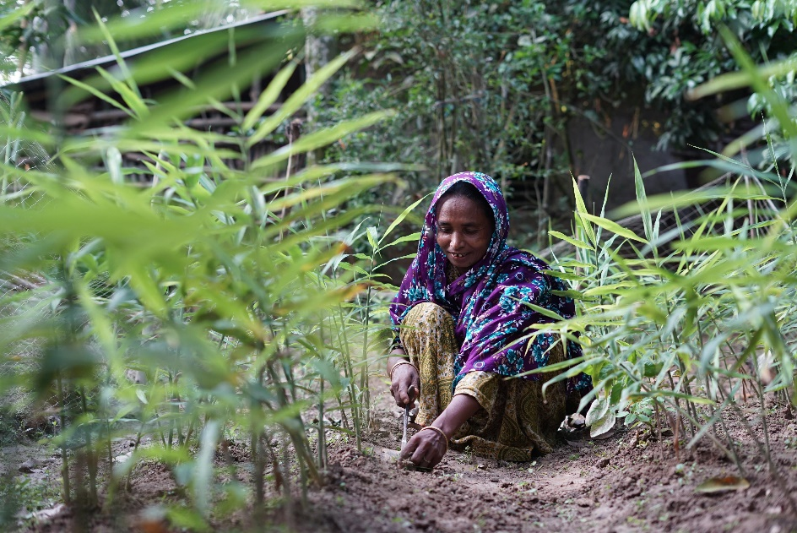

- Class Discussion – fifteen minutes

Ask students to break into pairs, spend ten minutes discussing the following:

- Do you think women have a role in finding a solution to the climate crisis?
- How can they help?
- What are the challenges of climate change for women’s rights?
- What do consumers need to do to support women’s rights and cut down on emissions?
- What kind of actions can we take to combat climate change?
- Do you think we can combat the impact of climate change in a way that is respectful of women’s rights?

Afterwards, take five minutes to ask students to call out answers and write them on the white board/flip chart.

- Reflections – two minutes

Ask students to spend two minutes reflecting in their notebooks, you can ask them the following questions to reflect on.
- What had you heard about climate change’s impact on women’s rights before and where? (from media, friends and family, just around)
- Who has the power and control regarding climate change’s impact on women’s rights? Who loses and who benefits?
- Whose perspectives do you usually hear from regarding climate change’s impact on women’s rights?

- Actions to take – three minutes
Go to the explainer of suggestions about how students can take action:

- Talk about the impact of climate change on women’s rights with your friends and family.
- As a class, discuss ways that you can work together with your community to take action.
- Write to your local politician or local newspaper outlining the changes that you would like to see.

(If your students would like support with taking further action you hand out our take action guides on our website – available here: https://actionaid.ie/speech-writing-competition)

- Take part in ActionAid’s ActionTalks speech writing competition, writing a speech on the topic:
- The climate crisis is causing devastation across the globe, affecting in particular countries in the Global South and particularly for women, driven by our dependence on fossil fuels. Unless the world urgently ends our reliance on fossil fuels, women’s rights will be denied and violated due to the impacts of climate change. Discuss.
- First prize is a €500 voucher – learn more at www.actionaid.ie

Further resources

- https://www.actionaid.org.uk/our-work/emergencies-disasters-humanitarian-response/climate-change-and-gender
- https://www.undp.org/blog/women-are-hit-hardest-disasters-so-why-are-responses-too-often-gender-blind
- https://youtu.be/CCcmS-foy3Q?si=3FPolcgNGnhvWYnV
- https://www.ohchr.org/sites/default/files/Documents/Issues/ClimateChange/materials/KMClimateChange.pdf

- Ideas for activities: https://adulteducationcityofdublinetb.ie/wp-content/uploads/2023/06/138530-CDETB-Climate-Justice-book-WEB-Version.pdf
- https://www.youth.ie/programmes/projects-initiatives/climate-justice/
- https://environmentalsolutions.mit.edu/wp-content/uploads/2023/10/A-Starter-Guide-for-Teaching-Climate-Environmental-Justice.pdf
- https://youtu.be/luO8phhdfsA
- https://youtu.be/2njn71TqkjA?feature=shared
- https://youtu.be/XIiSZ1hFLlc

