ActionAid - The leadership role of women during emergencies: Lesson Plan

40 minutes
Materials:
- Flipchart/White Board
- A3 Paper
- Markers
- Laptop and projector
- Notebooks and pens

Purpose: To teach the students about the importance of women leadership during emergencies
- Humanitarian crises - three minutes
Ask students to use their notepad and pen and spend three minutes writing down what they think humanitarian crises are. Students can then call out answers.
- Go to the explainer of Humanitarian crises – two minutes
Use the PowerPoint provided to show the explainer on humanitarian crises. Ask students to write down any of the additional points that they didn’t have:
- Humanitarian crises refers to an event or set of events that threaten the health, safety and livelihoods of many people.
- There are different types of crises:
- Disasters, such as earthquakes, tsunamis, floods, droughts, cyclones, epidemics.
- Man-made emergencies (armed conflicts, plane and train crashes, fires and industrial accidents).
- Complex emergencies, which often have a combination of natural and man-made elements, (food insecurity, armed conflicts, and displaced populations).
Read more here
- Women leadership in humanitarian crises - three minutes
Ask students to use their notepad and pen and spend three minutes writing down: How do you understand humanitarian response and who leads that? What is required?
Then you can also ask what they think the role of women during humanitarian crises is. Students can then call out answers.

- Go to the explainer of Women leadership in humanitarian crises – two minutes
Use the PowerPoint provided to share the explainer on humanitarian crises. Ask students to write down any of the additional points that they didn’t have:
Women’s leadership contributes to better disaster preparedness and risk reduction.
Thanks to the knowledge of their local environment and their proven skills in community mobilization, women can enhance humanitarian response to the benefit of communities.
Opening up space for women’s participation in humanitarian response and recovery contributes to further gender power transformations, gradually reducing women’s historical exclusion from accessing power.
Read more here
- Women leadership in humanitarian crises –EXAMPLE – 3 minutes

Women are often responsible for the care and emotional rebuilding of communities during and in the aftermath of a crisis, and they often have strong local knowledge and links with others in the area where they live, which is a critical resource during humanitarian response.
Gaza: Palestinian women in Gaza continue playing leading roles in humanitarian responses, while women’s contributions and expertise largely go unnoticed and ignored. Buthaina represents a model of women leaders for humanitarian actions and responses in contexts of crisis and wars. Buthaina, Director of Wefaq Association, a partner with ActionAid which is responding to the crisis by providing basic needs such as hot food, clothing, dignity kits and health kits as well as psychosocial support to people experiencing trauma. In response to the deteriorating sanitary conditions, Wefaq have installed 60 WASH units across 20 shelters specifically for women and girls.
Buthaina believes that Women’s leadership is necessary for effective humanitarian response as women are very close and familiar with the needs of their community and women. With her team, she continues the humanitarian work despite many challenges including continuous bombing and tightened blockade imposed on Gaza and limited humanitarian aid allowed to enter Gaza.

- Video about women and girls in humanitarian emergencies (five minutes)
https://youtu.be/_x15C-6lRJw
- True or False Presentation – five minutes

Use the PowerPoint provided: ask students to stand up. Point to one end of the room for false and the other end of the room for true. When you call out a statement ask students to move to one end of the room or the other. Ask students at each end why they are there.

Then move the PowerPoint on to reveal answers:
Conflicts, disasters and humanitarian emergencies impact women, girls, boys and men in the same way.
False. Gender, age, and socioeconomic and cultural backgrounds are some factors that affect how people are affected by a crisis.
Source: https://www.unocha.org/gender-equality-and-empowerment-women-and-girls
When disaster strikes, women and children are 14 times more likely than men to die.
True.
Source: https://www.undp.org/blog/women-are-hit-hardest-disasters-so-why-are-responses-too-often-gender-blind
Women and girls account for more than half of the world’s internally displaced people.
True
Source: https://www.unocha.org/gender-equality-and-empowerment-women-and-girls
- Case study – five minutes
Hala is a 23-year-old law student who works with Violet, ActionAid’s partner in north-west Syria.
Violet operates in the field of relief and humanitarian work, and providing support to displaced persons and refugees affected by disasters, catastrophes and wars. Their main focus is capacity building for youth and women, improved sanitation and health awareness in affected areas, quality education opportunities for young people living in camps or sites for the displaced.
Hala is currently working in a centre that Violet has set up as a safe space for women and children affected by the earthquake that struck Turkey & Syria on 6 February 2023. There they offer kids’ activities and mental health support for women. They also hold awareness sessions around the prevention of sexual abuse and exploitation and legal rights for women and girls.
In the immediate aftermath of the earthquake, Hala and her colleagues in the protection team were offering mental health support in camps set up for earthquake survivors.
‘The war impacted all Syrians, but women were impacted most. Because there are women who lost their breadwinners, became widowers, maybe [got] divorced or all [their] relatives have died. So [these women] became the breadwinners for [their] kids. All of this will impact their mental health.’
‘After 12 years of war, women are facing a lot of challenges and difficulties. There are many people who don’t reveal [the problems they are facing] since it is [around] mental [health]. They need trustworthy people to talk to and [to] feel there is a safe space, to [share] what’s happening with them, for us to be able to help them to recover and carry on [with] their lives after this catastrophe.’

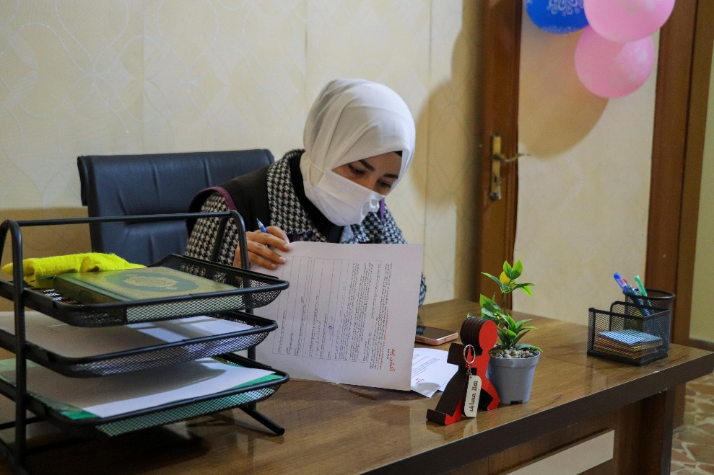

- Class Discussion – ten minutes

Ask students to break into pairs, spend five minutes discussing the following:

- What are the challenges for women during emergencies?
- What kind of actions can we take to support women to be better prepared for humanitarian crisis?
- Do you think women have a role in contributing to better disaster preparedness? If yes, how?

Afterwards, take five minutes to ask students to call out answers and write them on the white board/flip chart.

- Reflections – two minutes

Ask students to spend two minutes reflecting in their notebooks, you can ask them the following questions to reflect on.
- What had you heard about the leadership role of women during emergencies before and where had you heard about it? (from media, friends and family, just around)
- Who has the power and control when it comes to the leadership role of women during emergencies? Who loses and who benefits?
- Whose perspectives do you usually hear from when it comes to the leadership role of women during emergencies?

- Actions to take – three minutes

Turn back to the presentation and provide some suggestions of how students can take action:

- Talk about the leadership role of women during emergencies with your friends and family
- Discuss as a class ways that you can work together with your community to take action (e.g. carry out a survey in your community, organize and event or a workshop on the topic, create a newsletter)
- Write to your local politician or local newspaper outlining the changes that you would like to see

(If your students would like support with taking further action you hand out our take action guides on our website – available here: https://actionaid.ie/speech-writing-competition)

- Take part in ActionAid’s ActionTalks speech writing competition, writing a speech on the topic:
- During emergencies, climate disasters and conflict women experience higher levels of death, gender-based violence and marginalisation, and yet women are also critical to emergency responses, community cohesion and collective action. The leadership role of women during emergencies, conflict and climate disasters is overlooked, and yet is so important in preparing for and recovering from disasters. Discuss.
- First prize is a €500 voucher – learn more at www.actionaid.ie

Further resources
- https://youtu.be/u0g26wuOp_4?si=o2WOuTkOKvX6K4is
- https://youtu.be/gGoDeys0uPM?si=PJs4r0WMcVHMp8A-
- https://youtu.be/p4-TAbd39po?si=I3WyX2ctAiCToz0P
- https://youtu.be/0XQDzltSQ44?si=7PH2eVERchnompcC
- https://actionaid.org/sites/default/files/publications/ActionAid%27s%20Feminist%20Approach%20to%20Protection.pdf
- https://reliefweb.int/report/syrian-arab-republic/recognising-resilience-womens-leadership-northwest-syrias-earthquake-response-and-beyond-enar
- https://youtu.be/_x15C-6lRJw?si=Cqo9Ujch4e3WG75F
- https://youtu.be/EiOKFaIEVfM?si=nqgOSL8dVJDQytik
- https://youtu.be/fxqFFaPuQog

